# Introduction

The Danish Flexicurity model is well known worldwide, for being one of the most effective in keeping a low and stable unemployment rate compared to the other European countries (xyz). In 2008 Denmark had the second lowest unemployment rate in Europe, the mechanics of the flexicurity model leading to this result comes from the high level of flexibility coming from the security net in the form of unemployment benefits (Kongshøj). The unemployment benefits ensures that companies can be more flexible as worker unions given the higher benefits demand a lower termination period. (Kongshøj) puts up three main points of view in discussing the perspectives of the Danish flexicurity model. One of them being the deteriorations of the income insurance program, which is argued to be one of the main elements of the Danish flexicurity model, with the other main elements being an active labor market policy encouraging activation and upskilling of unemployed and a flexible labor market. A result of the deteriorations of the income insurance program has been that the workers unions have demanded a higher dismissal protection, in form of allowances when going to unemployment on parts of the private labor market weakening the flexibility. Another aspect of the generosity of the income insurance program is the fact that being part of the program is not mandatory this leads to an interesting aspect in that lower generosity leads to a lesser attraction towards the program, leading to a lower insurance rate, possibly harming the flexicurity model.

Looking at the development of the generosity in Denmark over time data from ADAM’s databank suggests that the compensation rate has been falling since 1990-2018:

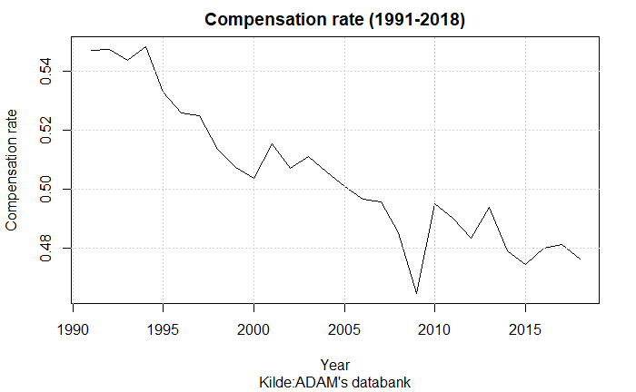

One of the major contributions to the falling compensation rate is the political regulations towards the determination of the maximum level of income insurance. In 1995 the Danish ministry of finance legislated a yearly regulation of unemployment benefits (xyz) The regulation goes through the rate regulation percent which is set to equal 2% each year added by the rate adjustment percent. The rate adjustment percent is each year set according to the adjustment percent which is calculated as the change in wages two years prior to the financial year subtracted by two percent points. If the adjustment percent is lower than 0%, the rate adjustment percent is equal to the adjustment percent. Is the adjustment percent between 0% and 0.3% the rate adjustment percent is 0%. Lastly, is the adjustment percent larger than 0.3% the rate adjustment percent is equal to the adjustment percent subtracted by 0.3 percent points. This creates a situation in which wage growth of more than 2% would result in the maximum level of income insurance not following the wage growth, making the compensation rate decline over time. The plot below gives an idea of how often the wage has increased by more than two percent.

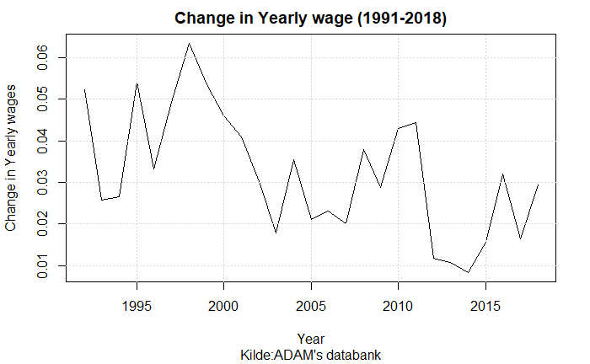

A more recent regulation is the one agreed upon in the Danish tax reform of 2012. One of the political initiatives in this reform was to suppress the regulations of employment benefits in the period of 2016-2023. Starting from 2016 the initiative would create a deduction of the rate regulation rate. The first year (2016) the deduction would be 0.3 percent points, next year 0.4 percent points and in the period 2018-2023 0.75 percent points. (Skattereform 2012)

Other studies discuss whether a third reason for a falling compensation rate should be included. When calculating the compensation rate the amount paid to labor market pensions from both the worker and employer is subtracted from the wage. Therefor a larger share of the wage paid to labor market pensions will result in a higher rate of decrease in the compensation rate. One of the argumentations for including the development in the share of the wage paid to labor market pensions is that employed will benefit from their pensions later in their lives.   
This third effect is not included in the graph showing the compensation over time, including this effect should up the rate of decrease and thereby make the fall in the compensation rate even larger since the worker insurance started in the 1960s paying 0.9% of the wage, but over time this percentage has increased hitting 12% in 2010, where it has mostly stayed fixed. (Finansministeriet)

In this paper we will focus on the period of 2005 -2020 within this period additional political initiatives were taken regarding the income insurance program. In 2010 a new income Insurance reform was agreed upon, decreasing the period in which an unemployed could receive income insurance from 4 years till 2 years, as well as increasing the requirements for receiving income insurance (xyz). Later, to make the cutoff date less strict updates to the period in which a person could receive insurance were redone making it a smoother transition from the 4-year period to instead 2 years. A more recent change after 2020 is the reform made in 2022 making two important adjustments to the IS-program. First, increasing the amount one can get in the first 3 months for people with a strong working history. Second, lowering the amount one can get going directly from education to unemployment. The effects of these reforms will not be included in the analysis.

Instead, this paper attempts to analyze the relationship between the macro and micro- economic effects of the initiative from the tax-reform presented in 2012, suppressing the rate regulation rate in the period of 2016-2023. We use a stock-flow consistent model as this enables us to include the effects of changes in the stocks of for example the households’ savings and government debt, which should be of great interest when assessing the policy regulations. All other studies trying to analyze the relationship between the micro and macro elasticity of income insurance on unemployment, have used boarder-based approaches, giving mixed results possibly duo to biased estimates (will be discussed later) a Stock-Flow consistent model will overcome these biases, and by comparing the results with a micro founded model from the income insurance commission 2015, we get an idea of the relationship of the micro and macro elasticity of income insurance on unemployment, making it possible to discuss the completion of the political initiative made in 2012.

This paper makes three important contributions. First, we develop an empirical SFC-model integrating the dynamics of the Danish labor market, specifically including the variables that are used for political regulation of the unemployment benefits. Second, we do a counterfactual analysis of the regulations made towards the unemployment benefits in the tax reform of 2012. Third, this paper contributes to the more recent focus on the aggregate effects of changes in the income insurance rate, looking at the relationship between the micro and macro effects of changes in income insurance.

The paper is organized as follows: Section 1 presented a short introduction of the political initiatives towards the income insurance program in Denmark, and its development over time. Section 2 will present the current literature on the different effects of changes to the income insurance program. Section 3 will take a closer look at the income insurance model build in 2015 and is strengths and weaknesses. In section 4 we will present a quarterly SFC-model for Denmark, specifically looking at the Danish labor market. In section 5 we present results of including different macroeconomic channels in the model. In section 6 we use the results from section 5 to get a relationship between the macro and micro elasticity of income insurance on unemployment and discuss the completion of the initiative from the tax reform of 2012. Lastly in section 7 we conclude the results.

# Section 2: Lit review

In the later years there has been a large amount of literature towards the effects of unemployment benefits. Mostly focusing on the link between the compensation rate and employment. A large part of the literature investigating the incentive to work and job-search, has been reviewed by (Andersen, 2015) they find that the majority of the literature show evidence for a higher movement from unemployment to employment when reducing the unemployment benefits, thereby increasing the exit-rate from unemployment. The two main effects associated with the exit-rate are the Moral Hazard and Liquidity effect, both build on a micro foundation. (Chetty, 2008) finds that the liquidity effects explain 60% of the effect on the unemployment period when changing the level of income insurance. In contrast (Howell/Azizoglu, 2011a) provide another micro founded link between unemployment benefits and work incentives as they find a positive relationship between working and happiness, independently of income insurance, thereby questioning the relationship between working and disutility.

(Andersen 2015) also address the approach effect again building on a micro foundation it shows that a relationship should exist between the movement from employment to unemployment and the level of income insurance, they add that at the given time the literature towards the approach rate is still sparse, not showing any significant movement when changing the level of income insurance or the period of the program. Newer literature presented in (Dørs 2022) shows that when looking at changes in the level of unemployment benefits there has only been one new study showing that increasing the level of income insurance by 10% increases the approach rate by 1.7-1.8 %. (Falch,2015).

One reason for the lack of new literature towards these effects building on a micro foundation presented above is given by (Dørs 2022) who points out the newer literature is moving away from the narrow point of only looking at the effects on the behavior of unemployed and employed which is empirically found using micro founded methods resulting in only the micro elasticity of income insurance on unemployment. To instead focus on aggregated effects of changes in the unemployment benefits, and thereby including the macroeconomic effects. (Fredriksson, Söderström 2020) looks at the aggregated effects of a reform in Sweden and finds that the number of unemployed increases by 3% when increasing the compensation rate by 1%. They find that this macro elasticity is twice as large as the elasticity coming from the micro founded effects of changing behavior of unemployed. On the other hand, a study by (Boone mfl 2021) finds that the aggregated effect is lower than the effect of the changing behavior, but still points out the importance in finding the relationship between the micro and macro elasticity. The empirical result at this point therefore seems inconclusive regarding adding more macroeconomic effects when looking at the aggregated effects of unemployment benefits.

In contrast to mainstream theory who builds there models looking mostly at the supply site using the presented micro founded effects, post-Keynesian literature determines the employment and real wages by looking at effective demand, this implies that an increase in the aggregate demand will raise the level of economic activity, creating more jobs. As Dray and Thirlwall (2011, p. 466) recall, ‘it makes little economic sense to think of growth as supply constrained if, within limits, demand can create its own supply’. This explains why we shall focus on the income distribution determinants of aggregate demand, paying less attention to the supply-side factors.

Looking at the unemployment benefits post-Keynesian theory suggests that through the demand channel a higher level of income insurance should lower the unemployment. Regarding the supply of labor, it has been argued that the decision to work along with conventional variables – such as wage rates – also depends on several factors, including norms, wages relative to other workers, consumption levels, and the standard of living. This implies that an increase in unemployment benefits may not force people to leave their jobs or stay unemployed for longer periods. (Mikael, Hamid)

In general, post-Keynesians have proposed redistributive policies, favoring an increase in social expenditures – including unemployment benefits – which are important for income distribution. In particular, two main distributive policies – namely pro-labour and pro-capital – are described by Lavoie/Stockhammer (2013) pro-labor distributional policies are those increasing the wage-share. Pro-capital distributional policies usually claim to promote ‘labour market flexibility’ or wage flexibility, rather than increasing capital income. Increases in the unemployment benefit is therefore seen as a pro-labor policy, if this expands the economy this is called a wage-led regime, on the other hand if this contracts the economy it indicates a profit-led regime.

The focus on income insurance in Denmark was very high leading to the Danish election in 2015. On the one hand a commission set down by the Danish Ministry of employment (IS-commission) to analyze the effects of income insurance in Denmark in 2015 presented a model build on the micro effects presented above estimating the change on the exit-rate and approach rate as a result of changes in the level of income insurance. On the other hand, worker unions and unemployment insurance companies in Denmark claims that this model are first of all not estimating the micro effects correctly but are most importantly missing the macro effects.

(CEVEA) argues that the behavioral effects (explained above) used to estimating the costs of an increase in the level of income insurance is miss leading. Especially they argue that the IS-commission is overstating the approach effects, stating that increasing the income insurance increases the approach towards unemployment for those employed. (xyz) also themselves states that there is very low empirical evidence for this effect even existing (“Der foreligger en relativt beskeden, udenlandske litteratur, der har undersøgt eksistensen og størrelsen af tilgangseffekter til ledighed.”)  
Also (xyz) add that they don’t see the income insurance at a level where it should be pulling employed into unemployment, they argue that looking at the group experiencing the highest level of compensation rate a large percentage of these are still in job.

More recently (DØR 2022) concludes that based on new literature the estimate of the approach effect given by the IS-commission when looking at changes in the level of income insurance is overstating the negative effect that the approach effect has on employment. They split up the analysis into three scenarios one being a change in the level of income insurance, they claim that the reason for the miss leading effect might be that the commission is only including one of four effects that should be playing into the approach effect.

The effect included by the commission, is that people in terminated positions will experience a higher exit rate when lowering the level of income insurance, thereby more people will go into employment before joining the income insurance program. The three other effects that (DØR 2022) argues should be added into the model are the following:

First, (Dør 2022) claim that the commission is neglecting the possible effect of changes in the level of income insurance on job separation meaning a change in the number of “opsigelser” or redundancies. As the higher level of income insurance will lower the costs for a worker losing his or her job. This could lead to a lower effort put in by the worker, increasing the change of the worker getting fired. Also, the fact that a higher level of income insurance could be a chance for the worker to reorganize his or hers working life, increasing the rate in which people go into the income insurance program. (Wang og Williamson, 1996) (Hopenhayn og Nicolini 2009)

Second, the change in level of income insurance could also have an effect on the job creation rate by reducing the number of advertised vacancies, this effect can be caused by higher costs for the firms both because they may have to advertise more if the job search is lower duo to an increase in the level of income insurance, or because of higher wages, as the level of income insurance plays in to the wage negotiations which will be discussed in section 3.

Third, they argue that the income insurance model doesn’t allow the change in behavior of the employed and unemployed can affect other people’s situation. The model is only looking at the individuals expected reaction to change in the income insurance program. As will be seen in section three, newer literature is having a larger focus of the aggregate effects of changes in the income insurance program.

One option to quantify the effects of changes in the compensation rate is by looking at the effect on the government finances, (CEVEA) splits up the effects in two, one being the immediate revenue effect, showing the direct expenses in the form of extra income insurance by for example increasing the level of income insurance, here it is also taken into account that a share of the higher level of income insurance is coming back in the form of taxes and other charges.   
The second effect is mentioned as the behavioral effects or dynamic effects, this is the effect of changes in the exit rate and approach rate, as mentioned above.   
(xyz) splits up the costs for three possible changes to the income insurance program, one of them being a cancelation of the suppressing of the rate regulation percentage for 2021, 2022 and 2023. The estimation of the expenses using the income insurance model created by the income insurance commission suggests that the expenses will be increased by 560% including the behavioral effects, where the exit rate will be contributing with 55% and the approach effect with 45% of the increase. Thereby the total expenses estimated by the income insurance model will be 1090 million kr. (xyz) criticizes the fact that 45% of the increase in expenses are coming from an effect that as mentioned above has no empirical evidence for existing.

In the next section we will present a more detailed description of the income insurance model build by the IS-commission, giving an idea of the micro elasticity of income insurance on unemployment for Denmark. As the model does not include aggregated effects, possible aggregated effects will then be presented.

# Section 3

The section above gives an introduction of literature towards changes of income insurance showing and that over time the focus has gone more towards estimating the full macroeconomic effect instead of only the mainstream economic view on the micro effects. This discussion has also played out in Denmark, where the income insurance model build by the IS- commission was med by a large amount of critics for neglecting macroeconomic effects of income insurance. In this section we will take a deeper look at the income insurance model, as well as the neglected macro effects.

## Dagpengemodellen

The model of income insurance was developed to analyze effects of political changes in the income insurance program for Denmark, consisting of four different parts: A static model for income insurance, a static model for “kontanthjælp”, a Markovmodel and lastly, a re-earning model. Only the first three parts will be presented now, as the re-earning model only concern changes towards rules for re-earning the right to income insurance, thereby not looking at the level of income insurance.

The static model of income insurance is developed to calculate the immediate economic effects for a specific person being unemployed when changing the level of income insurance. For this reason, this model will not include the behavioral changes that might happen, when creating changes in the income insurance program. Similarly, the effect on kontanthjælp is calculated using the static model for “kontanthjælp”.

The more interesting part is the Markovmodel which is built to calculate the equilibrium levels of employment and unemployment, to do this the population is divided into three groups: Receivers of income insurance, employed, and receivers of other social benefits. Within each group people are further divided into groups based on their “dagpengeanciennitet” (1-208 weeks) and “beskæftigelsesanciennitet” (0-3 quarters).   
The Markovmodel estimates the probability of changing in-between the three groups, thereby looking at changes in the exit rate and approach rate, the first Indicating that a change in the level of income insurance changes the departure from unemployment to employment in the period up until the reduction and in the period immediately after. This effect is mostly concerned the unemployed with the best job opportunities to get off income insurance. The model is estimated using the 2010 reform mentioned in the introduction which shows an effect up till 78 weeks before the reduction in income insurance till 26 weeks after, this can be seen from the effect staircase shown below.

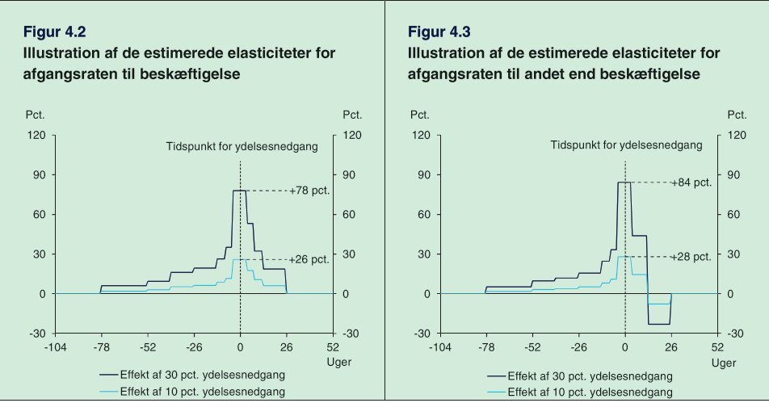

The behavioral effects are specified as elasticities meaning that a relative change in the exit rate from unemployment to employment is a function of the relative change in the gross compensation rate. Thereby the effects of an increase in the compensation rate of 30 and 10% will following their estimates have the effects of increasing the exit rate by 78% and 26%:

Besides the effect of the exit rate, the IS-commission also includes the approach rate, as mentioned in section 2 the commission only includes one of four effects on the approach rate argued by (DØRS 2022). The commission looks at if people on their way into the income insurance program will find employment before entering the program. One issue is that data can’t show how many people are on their way to enter the income insurance program or how large their exit rates to employment is.

Therefor the commission must assume that the behavioral effects for people being close to going into the insurance program (fx from terminated positions) are comparable to the behavioral effects of people already being in the income insurance program and thereby have been in unemployment in up till 2 years.

The commission use this assumption to create a baseline for the exit rate to employment, for employed in terminated positions. Three additional assumptions are made to construct the exit rates for this group:

1. They assume the exit rate is 0% 26 weeks before entering the income insurance program (as there are 6 months of termination period)
2. The exit rate is assumed to be linear going from 26 weeks before joining the program till the first week of joining the program
3. The exit rate is the same just before joining the insurance program as right after. Meaning the green and red line should meet at week 0

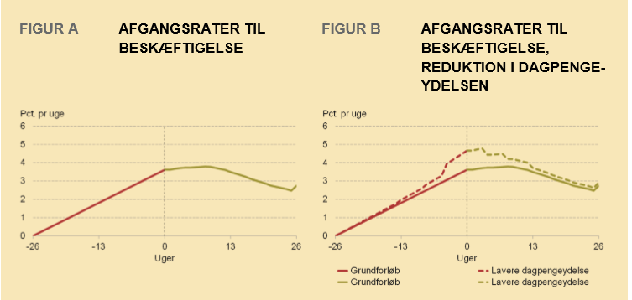

(DØR 2022) Argues that there are missing empirical evidence for all three assumptions, they claim that people on income insurance might have more time for job searching than people being in terminated positions. On the other hand, they expect people being close to joining the income insurance program to increase their job search to avoid the fall in income.

As seen above the estimated behavioral effects from a 10% decrease in the level of income insurance indicates a 26% increase in the exit rate in the start of the unemployment period This effect is included in figure B by increasing the exit rate by the values estimated from the effect staircase. Meaning a 26% increase in the exit rate in week 0.

From figure B we can now see the effect of an increase in the exit rate for people in terminated positions by looking at the change in the red line showing the change in the exit rate prior to joining the income insurance program. Therefor less will join the income insurance program, when decreasing the level of income insurance. As significant effects are found up till 78 weeks before the change in the level of income insurance for the exit rate, changes in the level of income insurance in the first 78 weeks of the income insurance program will influence the approach rate. (With lower effects the later the increase appears)

## Empirical evidence of the income insurance model

Most of the empirical evidence used for the income insurance model comes from the literature review made by (Andersen. 2015) This review was made specifically for the income insurance commission, and therefore influenced the effects used in the income insurance model.

In one of the sections of (Andersen, 2015) They look specifically at the literature concerning a rise in the level of income insurance. They present 28 different older and newer studies looking at the exit rate from the income insurance program to employment. Looking at an increase in the level of income insurance, they find that 24 of these studies conclude a significant negative effect of the exit rate, the last 4 studies conclude non-significant negative effects.

The two main theories explaining these results are the Moral Hazard effect, and liquidity constraints. The most commonly used explanation for the negative effects is the Moral Hazard effect, where an increase in the level of income insurance will result in lower incentive to search for a new job, and in addition to this also be pickier regarding job offers increasing the unemployment period.

(Chetty) presents the other alternative explanation to why an increase in the level of income insurance increases the period in which people are unemployed. Claiming that unemployed are experiencing a budget constraint, as they are using their savings to keep a higher level of consumption. When one’s savings are running low (which will take longer the higher the level of income insurance), that person might be more likely to accept jobs that are not socially efficient. This effect will thereby lead to a worse job match between employer and employed, not taking advantage of the higher productivity the employer could have had in another job position with a better match. (Chetty) finds that the liquidity effect explains 60% of the effect on the unemployment period from an increase in the level of income insurance.

In another section (Andersen, 2015) looks at the empirical evidence found for the effect of liquidity constraints on the quality of a job-match. The effect can arise through heterogeneity for both companies and workers that matters for a job-match. It will take time and costs for both companies and workers to localize a good match. In Addition to this there will be a lock-in effect as there are associated costs of firing/quitting and finding a new employer/employed. This means that workers might not be in the job where they are maximizing their productivity, and reallocation of the working force could therefore lead to a higher output.

Therefor when increasing the level of income insurance, there will be a decrease in job search lowering the employment quantitively, but the quality might increase duo to the above-mentioned effect. (Andersen) presents two measures for the quality of the working force, the wage and hiring period. The challenging part being to control for other effects, affecting the wage and hiring period.

(Andersen) presents several studies, all indicating that a more generous income insurance program results in extended unemployment period, approximately half of the studies finds positive effects on the match-quality, the other half finds no effects, and one study find significant negative effects (most of these are from the US and might not be representative).

(Andersen, 2015) points out that the majority of the literature has been based on change in the behavior of unemployed thereby not taking into account that the change in behavior could also affect the situation for other actors in the labor market. At the time of writing (Andersen 2015) mentions that there isn’t much literature looking at these aggregated effects for changes in income insurance. But one effect starting to get more attention is the wage-effect which explains how a change in the level of income insurance will affect the wage negotiations, where you would expect that a higher level of income insurance would increase the targeted wages demanded of the worker unions, to keep a high incentive to work. As the literature presented by (Andersen, 2015) looks at a micro level, where the wage will have a negative effect in the form of lowering the demand for labor reducing the number of unemployed. The rational is different in another study by (Mikael, Hamid) who uses the framework of a theoretical stock-flow consistent model, also including the compensation rate in the wage equation, together with the rate of employment, and productivity. The inclusion of the compensation rate in a stock-flow-consistent framework is an addition to the model used by (Godley/Lavoie 2012), (Mikael Hamid) Argues that incorporating the compensation rate is in line with standard models of wage setting, which plays an important role in the determination of the targeted wage (xyz). The change in wages will then affect the wage-share of the economy and depending on if the country is wage-led or profit-led as discussed in (stockhammer) the unemployment will be positively or negatively affected.

(ADAM) also includes a link between the compensation rate and the wages, the link goes through the structural unemployment, which is positively affected by the compensation rate, meaning an increase in the compensation rate increases the structural unemployment. In the wage equation the difference between the unemployment and structural unemployment is affecting the wages in the next period negatively. This creates a situation where employment above the structural employment worsens the wage negotiations for workers and thereby negatively affects the wages.

Maybe shortly mention the insurance rate again, and that many are saying this should be included in the estimates. As ill use it in the next section as one of the effects included. It has already been presented in the previous section though…

In the next section, we will analyze some of the most important effects (argued by the literature) not included in the income insurance model. We want to include the link between the compensation rate and the rate in which people want to be a member of the income insurance programs, this effect is not commented on by (Andersen), but as seen in the section 2, a large group claims that this effect should be included. Next, we will also look at the effect of the maximum level of income insurance on the targeted wage, and how this affects the wage negotiating process. Lastly, we will look at the match-effect as a result of the liquidity effect, by endogenizing the productivity of workers. These different channels will be included to get an idea of how the suppressing of the rate regulation has affected the Danish economy, to later be able to discuss if these aggregated effects changes together with the results of the income insurance model validates the suppressing of the rate regulation percentage.

# Model description

The focus of this model will be to analyze the macroeconomic effects that the literature finds but are missing in the income insurance model created by the (commission 2015) using the political incentive to suppress the rate regulation percentage starting from 2016. To do so, we utilize the features of a stock-flow consistent framework and build upon the existing empirical stock flow consistent model for Denmark developed by (Mikael, Hamid, Sebastian). The dynamics of the model should be able to explain the macroeconomic effects from these channels not included in the income insurance model when analyzing political regulations of the maximum income insurance. This section will focus on the central equations added to include the new dynamics. First, creating a baseline model where only the demand channel is analyzed, after validating the baseline model the wage, productivity, and insurance rate channels are added to the model to analyze the economic effects of each shock. Lastly, we look at a scenario where all the three channels. In all the scenarios we look at the effect of removing the suppressing of the rate regulation percent, in the last scenario we also test a more radical decision to allow the maximum level of income insurance to follow the wage growth one to one.

## Baseline model labor equations

One of the most central inclusions to the labor market equations, is the inclusion of the maximum level of income insurance. Once every year the ministry of finance will set the maximum level of income insurance as of why the variable will only change in the 1. Quarter in the model and stay fixed for the rest of the year. In the baseline model “max_dp” follows the political regulations stated in the introduction. It follows that the maximum level of income insurance grows by the state regulation percentage plus the rate adjustment percentage each year.

As the Ministry of Finance determine the state regulation percentage it is held exogenous in the model. On the other hand, the rate adjustment percentage is calculated each year, using the adaption percentage. To match what was explained in the introduction we need to set up three conditions: First, if the adaption percentage is lower than 0 rate adjustment percentage is equal to the adaption percentage. Second, if the adaption percentage is between 0.0 - 0.3% the rate adjustment percentage is set to 0. Third, if the adaption percentage is above 0.3% the rate adjustment percentage is equal to the adaption percentage minus 0.3% points.   
As with “max_dp” the rate adjustment percentage is calculated in the 1. Quarter and held fixed to the end of the year.

The adaption percentage is calculated by taking the wage growth two years before the financial year subtracted by 2% point, it should be noted that we use the yearly wage growth, which in the model is calculated using the 1. Quarter, therefor the adaption percentage is only calculated for 1. Quarter and held constant for the rest of the year.

The endogenization of “max_dp” is now completed within the model and allows us to calculate the compensation rate within the model estimated as the fraction of the average amount an unemployed on income insurance would receive (dp_person), to the average wage received given employment (wage_ds).

To calculate dp_person we use a simple ols regression linking the maximum level of income insurance to the average benefits received by unemployed eligible for income insurance. This is done as an alternative of using aggregated data of benefits received by households, as the gap between observed unemployment and estimated unemployment in the model is large, creating a lower average of benefits received. We also prefer the regression as we can capture the direct effect of an increased level of maximum income insurance but at the same time, we know that only around 85% eligible for income insurance receive the maximum level meaning that the increase for the people not getting the maximum level would be less. For this reason, we know that the coefficient should be between 0.85 and 1, and most likely closest to 1. This is also observed as the coefficient estimated is 0.9507 observed below.

The average level of income insurance is then transformed into an aggregate variable, multiplying it by the unemployed, and the insurance rate giving the total amount paid in income insurance to the households.

The total amount paid in income insurance to the households then feeds into the households’ disposable income feeding into the production in the economy, this summarizes the demand channel created in the model, not accounted for in the income insurance model.

The total amount of income insurance also feeds into the net lending’s of the government, here it is assumed that the government finances the entire amount, the effect of changes in the level of income insurance will therefor overshoot the effect on government net lending. It is accounted for, that changes in income insurance also affects the taxes coming from households to the government.

One of the key variables in the labor market is the participation rate, showing the ratio of the population being in the labor force. In the baseline model we keep this variable as exogenous. A main reason for having the participation rare exogenous in the baseline model is that within the dynamics of the Danish labor market, many have failed to determine what brings people into the labor force, and as literature points out in section 2 where participation in the labor market can be argued to follow several factors, including norms, wages relative to other workers, consumption levels, and the standard of living.

## Validation of the model

In this section we look at the performance of the model, comparing the results from the simulation of the baseline model with actual data, with a specific focus on the variables in the labor market.

In the figure below we compare the simulated and actual data for GDP, Employment, maximum level of income insurance, compensation rate, disposable income, and government expenditures.

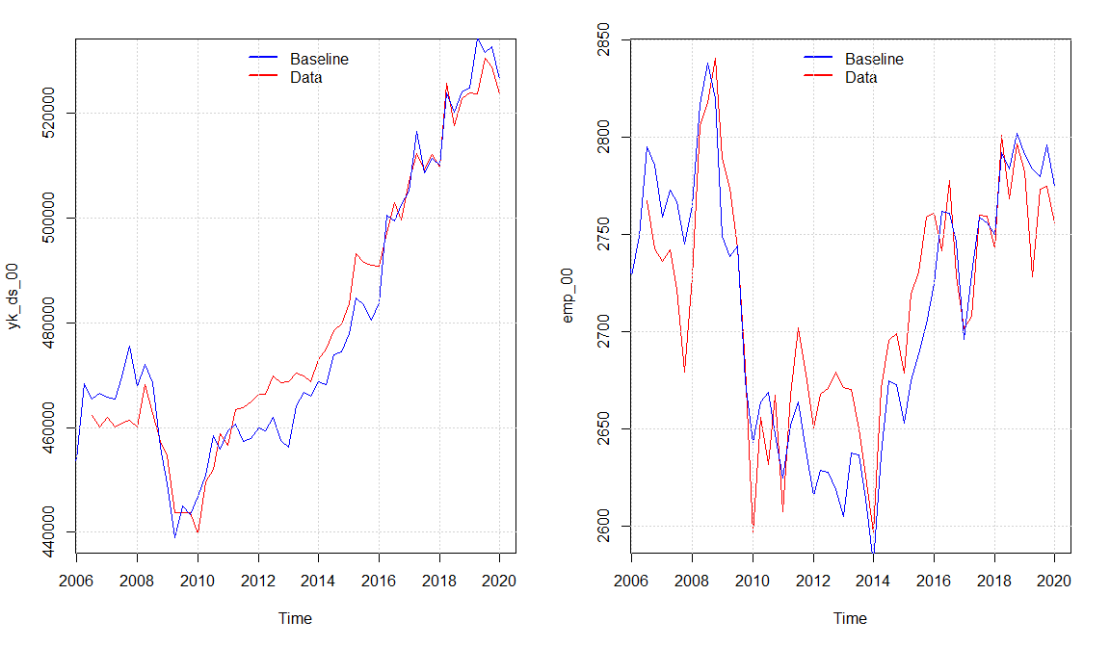

We observe that the model seems to capture the same dynamics of the real economy as (Mikael, Hamid, Sebastian) with a small overshooting in the economic activity in the period 2011 - 2016 explained by a higher simulated value of real investment and consumption compared with the data. Overall, the model seems to capture the medium to long-run tendency of the data even though there are some divergences in some quarters. The Overshooting in the activity also results in a higher level of the maximum level of income insurance in some periods when looking at the baseline model. As the increase in wage growth goes directly into the compensation rate in the same period, meanwhile the maximum level of income insurance will be affected with a lag of 2 years, we observe that the compensation rate is a bit higher in the baseline compared with real data around 2010 - 2012, but as the adjustments happens it goes back to follow the real data.

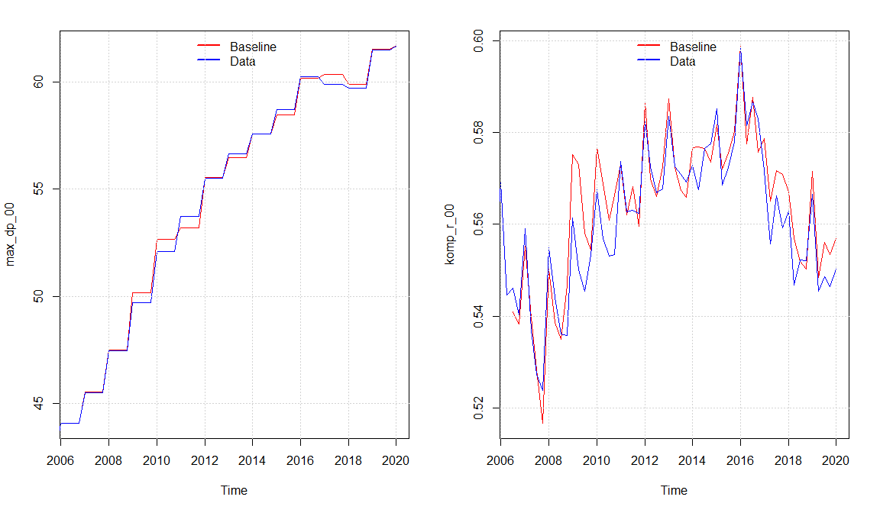

We can see that the compensation rate is slightly increasing, especially from around 2008-2016, one of the reasons is an ongoing slowdown in the growth rate of the wages. Comparing with the results of (DØRS 2015) the development fits very well, they as well use a macro-based calculation of the compensation rate. Most importantly we see a fall in the compensation rate in the years of suppressing the regulation of the maximum level of income insurance from 2016. Which was also expected looking at the results of (DØRS 2015).

Overall, we see that the data for the labor market is well replicated by the model, creating a basis for analyzing the neglected macroeconomic effects looking at the aggregate level results of changes in the level of income insurance specifically looking at the suppressing at the rate regulation rate.

## Scenario 1 No suppressing of the rate regulation percent

In this first scenario we will perform a counter factual shock removing the suppressing of the rate regulation percentage introduced in the tax reform of 2012. Instead, the rate regulation percentage will be held fixed at 2% but still subtracted the rate adjustment percent. As expected, this raises the average income insurance as people having the maximum level of income insurance will experience an increase in their income insurance. The increase in the average income insurance will go directly into the compensation rate. Both increase by approximately 3.5% in the period of 2016-2023, which can be seen below.

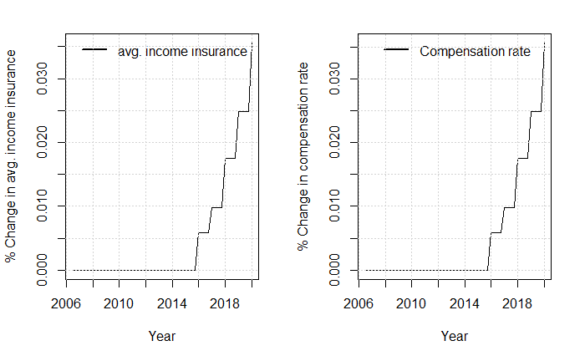

The increase in the average level of income insurance, increases the net social benefits received by the households, and thereby raises the disposable income of the households. As the increase in net social benefits for the households are financed by the government the net lending of the government will fall. These effects take into account the increased tax payments that the households will experience.

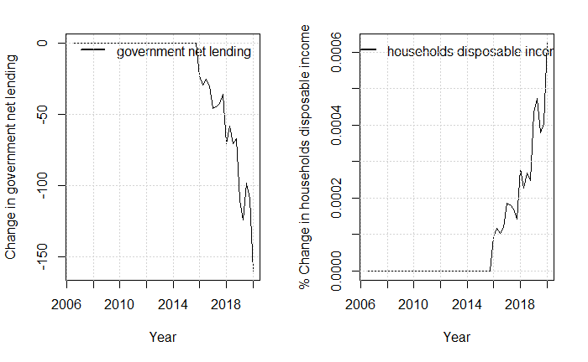

The increase in disposable income increases the consumption and therefor also the GDP. The increase in GDP will increase the firms demand for jobs and thereby raise employment.

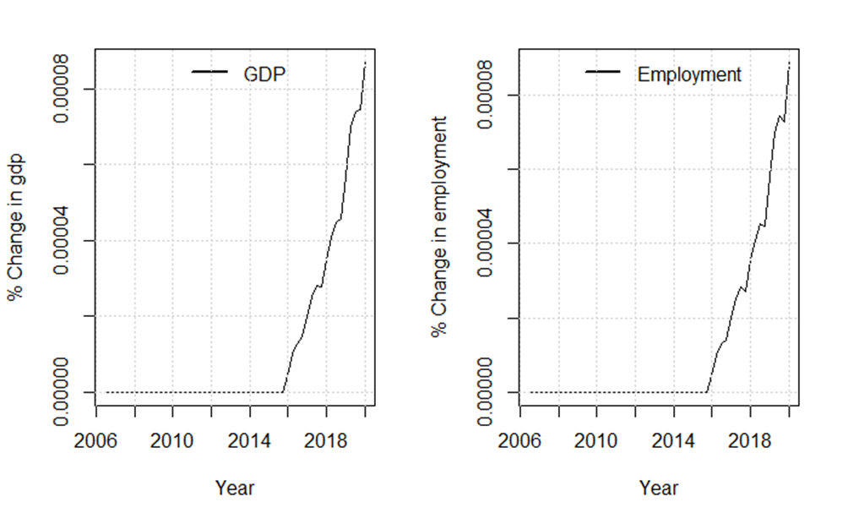

The only effect of removing the suppressing of the rate regulation percent in scenario 1 goes through the demand channel. As it is only a minor part of the population experiencing an increase in income, the macroeconomic effects are minimal but seems to expand the economy. Calculating the change in employment coming through the demand channel we get that employment increases with approximately 250 people. One of the most central estimates when analyzing the demand channel is the one going into the equation of the average income insurance. We know that the estimate should be between 0.85 and 1 as the fraction of receivers of the maximum level of income insurance is 0.85. And no more than 100% can receive the maximum level. Testing the sensitivity of this estimate using the two extremes in 0.85 and 1 we get a span in for the change in employment of adding 222 - 254.

In the next scenario a wage channel will be added to the model while still creating the same counterfactual scenario in removing the suppressing of the rate regulation rate.

## Scenario 2 Including income insurance in the wage negotiations

Besides the channel in which a higher level of maximum income insurance stimulates the economy through a higher demand, it also plays into the wage bargaining dynamics, as presented in the literature of section 3. The wage bargaining in the model is created through a targeted wage (wage_ds_t) which is set by the labor unions going into the wage negotiations. The labor unions got two agendas when determining the target wages. First, they want the wage to follow inflation so that workers keep their purchasing power over time. Second, they set a threshold for the minimum wage gap, in the model this is 40% of the wage, they would want to keep this gap between the wage and the maximum level of income insurance, to make sure that there will still be a strong incentive for people to go into employment. In the case where inflation is not able to close this gap alone (thereby leaving the gap to be below 40% of the wage), the labor unions would set the target wage so that the wage gap is exactly 40% of the wage. The equation for the target wage and the wage gap can be seen below:

The targeted wage is then included in the behavioral equation determining the wage, estimated to have a positive effect on the wage in the long run.

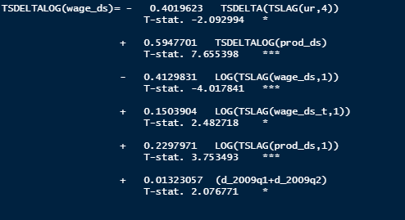

Performing the same shock as in scenario 1 by removing the suppressing of the rate regulation rate, we see that the targeted wage increases by almost 0.6% when introducing the shock to the right in the plot below that the wage gap now increases as the duo to the increase in the targeted wage, but ends under the scenario 1 wage gap, the reason for this is that the wage is now higher lowering the ratio.

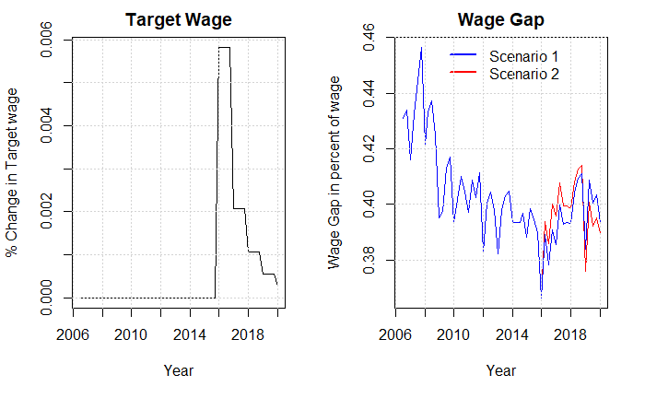

This effect happens as we see the wage negotiations are affected of the increase in the targeted wage, and thereby increasing the wages, as the firms are now experiencing higher costs, this will go into the consumer prices.

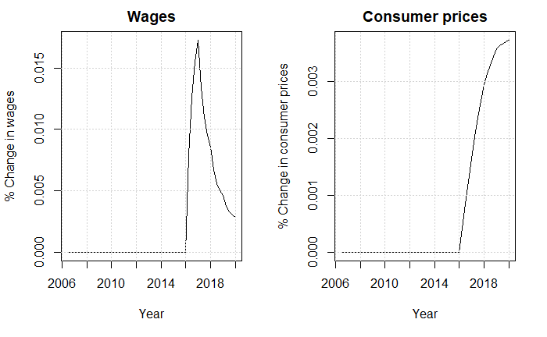

As the wages increase, so does the wage-share in the model. (Onaran Galanis 2013) argues that if the total effect of an increasing wage-share is positive, the demand regime is called wage-led; otherwise, the regime is labeled profit-led. They also argue that small open economies (as Denmark) usually are profit-led, thereby expecting a contraction of the economy. In the end it comes down to the effect on consumption, investments, and the trade balance of the economy.

The increase in prices will increase the real exchange rate lowering the export, we see this effect on the net balance right after the shock. After decreasing it starts to bounce back and in 2020 ends above the baseline model. The reason for this is that import is falling even more than the export in the end of the period, duo to a fall in the economic activity.

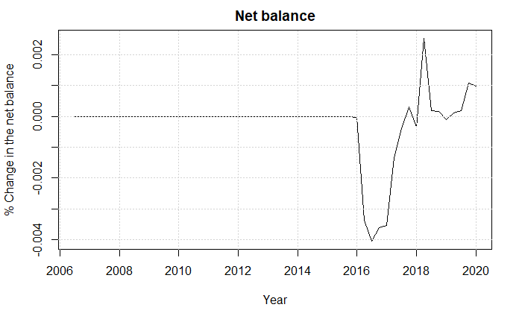

To analyze why we see a fall in the economic activity we start by looking at the consumption and investment. We observe a fall in the investments, as the wages increase, this creates an increase in the wage share and thereby lowering the profit share. As the profit share goes directly into the investments of the firms this decreases the future investments

The consumption increases in the start of the period as the higher wages results in a higher disposable income, and thereby increasing the consumption.

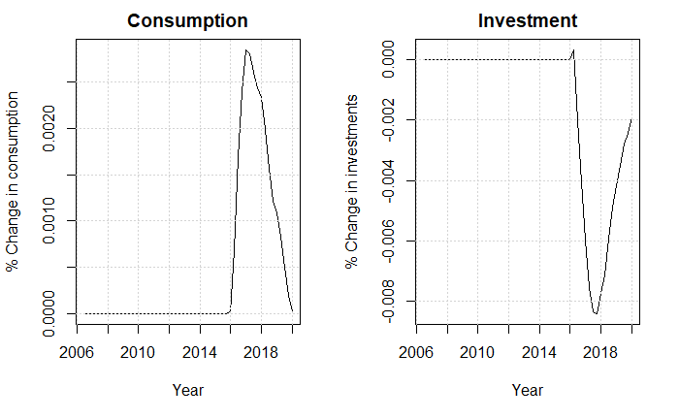

At the end we can conclude that the fall in investments is larger than the increase in consumption and trade balance therefor decreasing GDP and employment. The fall in employment as a result of removing the suppressing of the rate regulation rate is a fall of approximately 100 people in 2020, as will be seen in the sensitivity analysis changes to the parameter of the maximum level of wage gap allowed of the worker unions will create large differences in the change of the effect on unemployment. In the next section we will add a new channel in affecting the insurance rate.

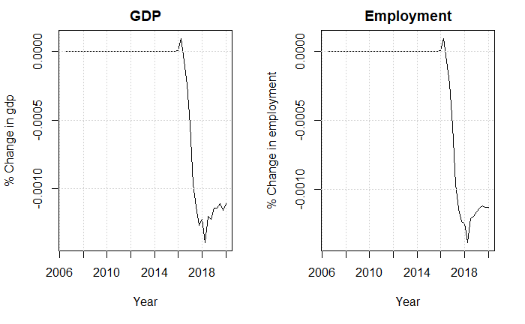

## Scenario 3 Effect of compensation rate on the insurance rate

In the baseline model the insurance rate is set exogenous, but as presented in section 2 many unions criticize the income insurance model for not including the fact that the compensation rate should impact people’s choice in joining the program. The literature mentions that we should expect the workers with lowest chance of becoming unemployed to be the first to pivot away from the program duo to a falling compensation rate, this effect will not be included in the model. Still there will be an effect on the demand site of the economy when a higher percentage receives income insurance when unemployed. The equation added to the model can be observed below:

It should be noted that the data for the percentage of people being a member of the income insurance program is based on data from ADAMS databank, therefor we only estimate the equation till 2017 quarter 4 as the variable is constant after this period. We find a positive long-run relationship between the compensation rate and the insurance rate; the results are significant at a 10% significant-level.

Again, implementing the same shock as in scenario 1 we can start by looking at the benefits received by the households, we see that the increase in compensation rate increases the incentive to join the insurance program thereby a higher percentage of the unemployed will be receiving income insurance increasing the net benefits received by the households.

When the net benefits of the households increase the net lending of the government will decrease, as it is assumed that the government is financing the increase in income insurance paid to the households.

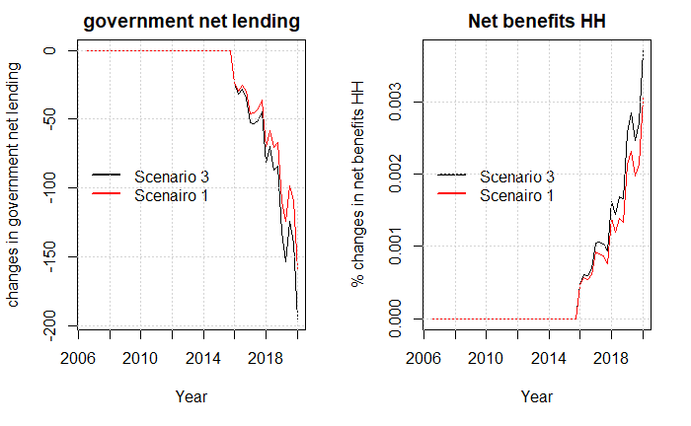

It shows that endogenizing the insurance rate, creates an extra demand effect than the one seen in scenario 1. In the plot below the effect of GDP of the shock in scenario 1 with and without adding the insurance rate channel.

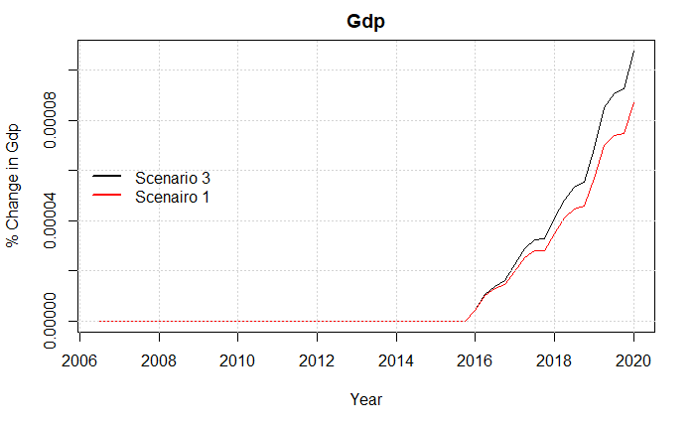

Lastly, we can look at the effect of employment and the unemployment rate where we can see that the effect increases the employment and lowers the employment rate compared to when not including the insurance rate channel.

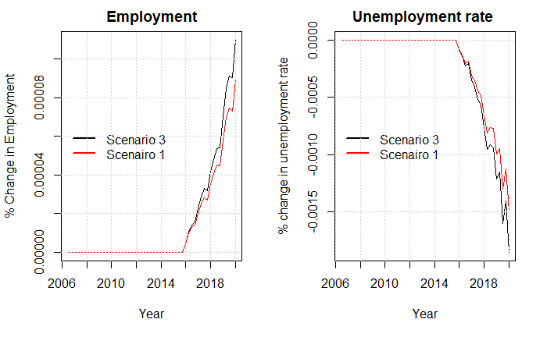

## Scenario 4 effect of maximum level of income insurance on participation

The endogenization of the participation rate happens with a few changes in the model. For now, the participation rate is exogenous and goes into the function defining the labor force as a fraction of the overall population.

The development in the participation rate has over the years been “biased” as a result of an increasing ratio of older people in the population. Therefore, we created a new participation rate only looking at the population below 65 years of age. The difference in the two participation rates can be observed by the figure below, with the figure on the right-hand site being the newly calculate participation rate.

We can see a difference in the trend of the two variables, where the participation rate of the population being younger than 65 years slopes upwards. As mentioned in section 2 and 3, the income insurance model considers the relationship between “kontanthjælp” and income insurance when determining whether to stay at the labor market. The same type of argument is used here where we include the ratio between “kontanthjælp” and the avg. level of income insurance received by households. The other explaining variables being the real wage and the unemployment rate, following the work of (Mikael Hamid). This creates a new channel for max_dp to affect the economy as an increase in max_dp will increase the avg. income insurance and thereby lower the ratio of kontanthjælp to avg. level of income insurance. We find a negative relationship between the kontanthjælps-ratio and participation-rate in the long run, indicating that people would rather stay in the labor force when the income insurance is high compared to benefits outside the labor force in the form of kontanthjælp.

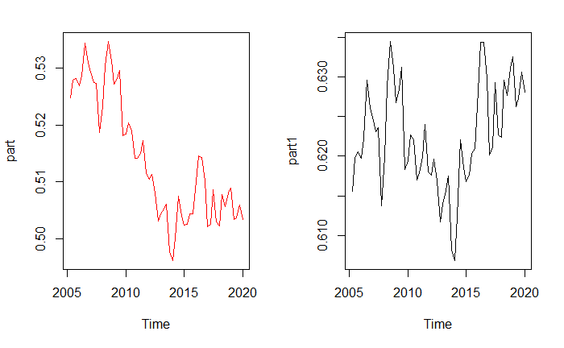

In the graph bellow we can observe the participation rate for the entire population before and after the endogenization of the participation rate, when performing scenario 1. We observe that the participation rate increases, as more people are actively searching for jobs when the level of income insurance is larger.

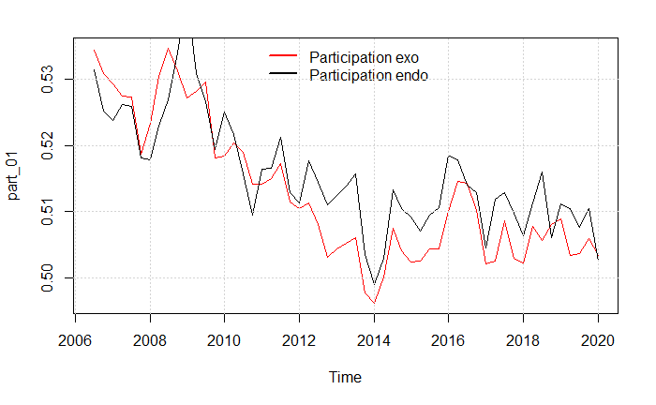

Not sure I will be including this shock as it only creates fluctuations but no real changes in the shock

Please look at graph below

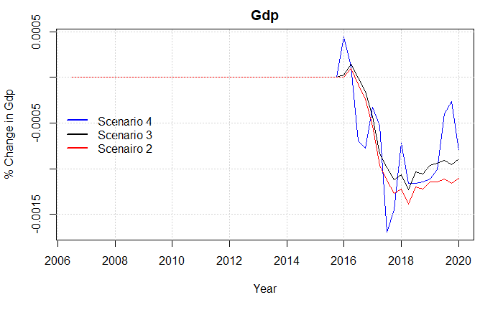

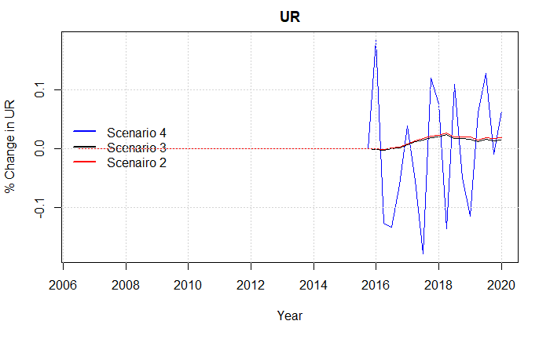

## Scenario 4 Including the matching effect

As argued by (Chetty, 2008) 60% of the change in the unemployment period duo to changes in the level of income insurance is caused by the liquidity effect. This creates a possible additional channel in the form of the matching effect, where increases in the level of income insurance affects the productivity as unemployed are more financially robust to stay longer time unemployed searching for a better job-match. As mentioned in section 3 empirical results are only finding weak evidence for the existing of the matching effect having an effect on the productivity, mostly in finding a realistic proxy for the productivity. The effect is included in the model by endogenizing the productivity function, making it a function of household savings and average amount of income insurance per person, as can be observed below.



The results show significant short and long-run effects for both household savings and average level of income insurance per person, even though the short-run effects are significant, those are removed as the effect in productivity is assumed to be in the long-run only. We see that both savings and average level of income insurance has positive effects on productivity, which is in line with the theory of the liquidity and match effect.

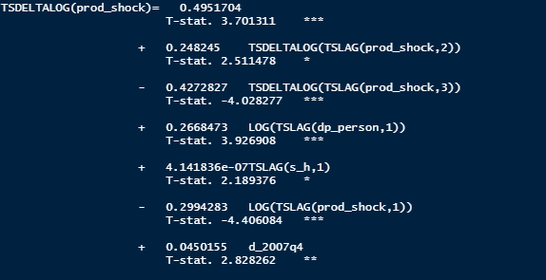

As the increase in the average level of income insurance now feeds directly into the productivity, we below observe an increase in productivity compared to the baseline model after 2016.

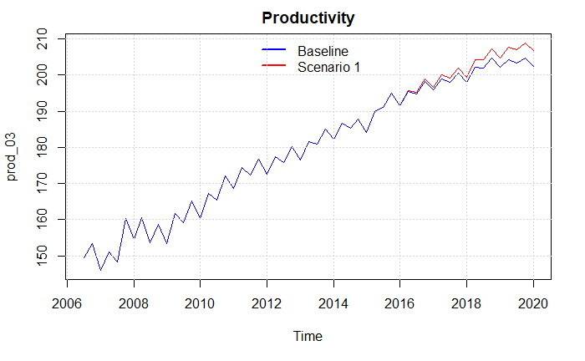

As the economy in a post-Keynesian SFC model is demand driven this goes for the labor market as well, therefor when increasing the productivity while having the same demand, firms will lower the number of workers to meet the same level of demand, therefor decreasing the number of employed in the economy by around 50.000 which is a 2 percent drop in number of unemployed, at the same time we see an increase in the economic activity both observed in the plot below.

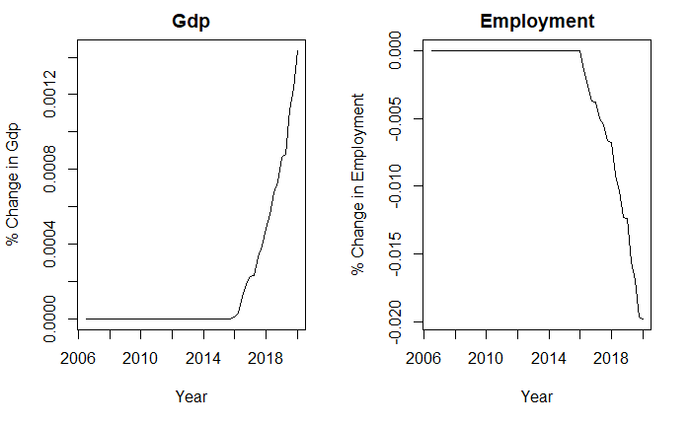

This effect compared to the other effects are quite large, looking at the sensitivity of this shock we find that changes in the estimate of 0.26 for the average level of income insurance per person plays a large role in the fall of employment, lowering the estimate to 0.1 reduces the fall in employment to only around 3000.

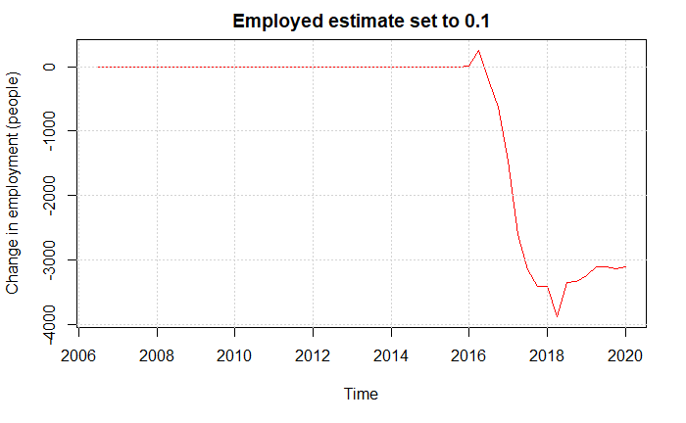

## Scenario 5 All effects

From the previous scenarios we could see how including the additional effects one by one effected the economy, therefor we will now introduce a scenario including all the channels in the economy discussed so far. As the productivity channel is the one least empirically justified, we also look at a case where this is excluded.

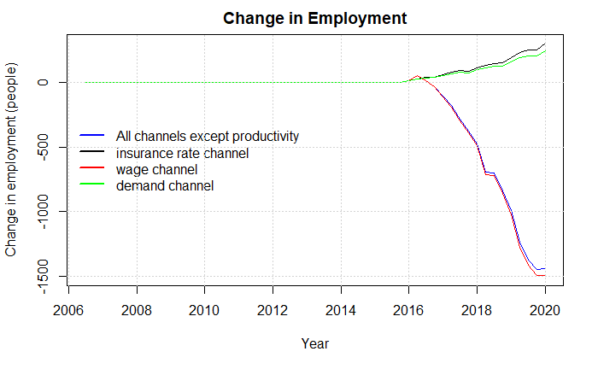

We can see that adding in all the effects despite the productivity shock results in almost the same result as the scenario including only the wage-channel, but the increased demand from scenario 1 and 3 does so the fall is marginally smaller . Looking at the effect on government net lending we can see the effect on the graph below, showing that all the effects sems to affect the net-lending negatively.

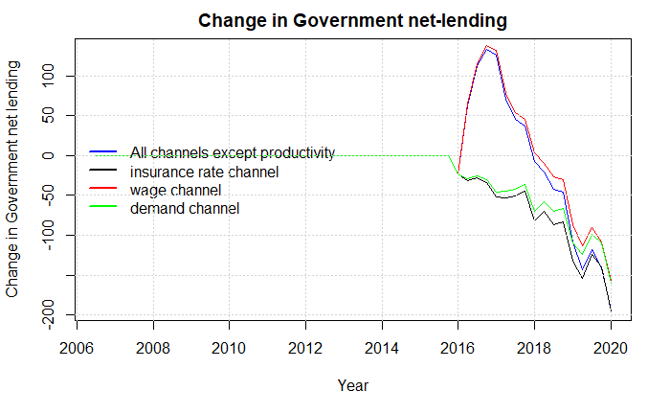

We can also compare the effects on GDP, also now including the case where productivity is included with all the other effects.

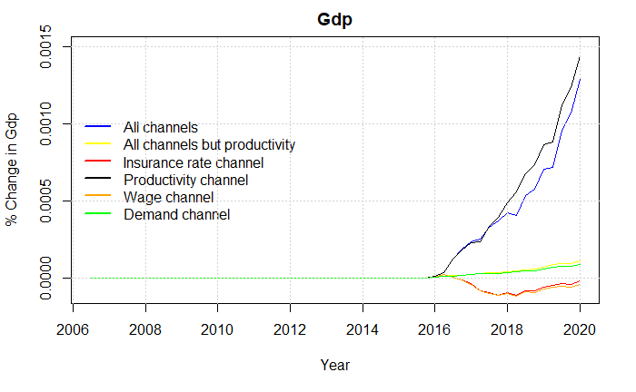

Isolating the case in which productivity is included we can also look at the effect on employment and net lending. Here we especially see how the productivity has a much larger effect on employment.

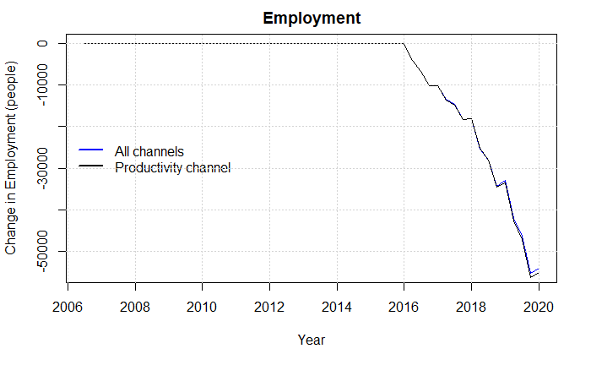

In all the scenarios up until now, we have been looking at the effects of removing the suppressing of the rate regulation rate, finding no till little overall macroeconomic effect on employment when not including the questionable productivity channel.

We now look at a longer and more radical shock by changing the equation for the maximum level of income insurance, so that it follows the growth in wages from two years before the financial year. Therefore, this scenario will show the counterfactual situation in which the maximum level of income insurance will no longer be subtracted by up till 0.3% each time the growth in wages exceeds 2%. Also, the regulation from the 2012 tax reform is removed in this scenario as in the prior scenarios. The new equation for the maximum level of income insurance takes the following form:



We keep using the wage growth two years before the financial year for consistency, as the (quit large) increases in 2003 and 2004 would inflate max_dp in the baseline but not in this scenario. As a result of the shock, we would expect max_dp to increase even more than in scenario 1. As can be seen from the graph below max_dp increases by almost 6% from 2006q3 till 2020q1 compared with approximately 3.5% we saw before.

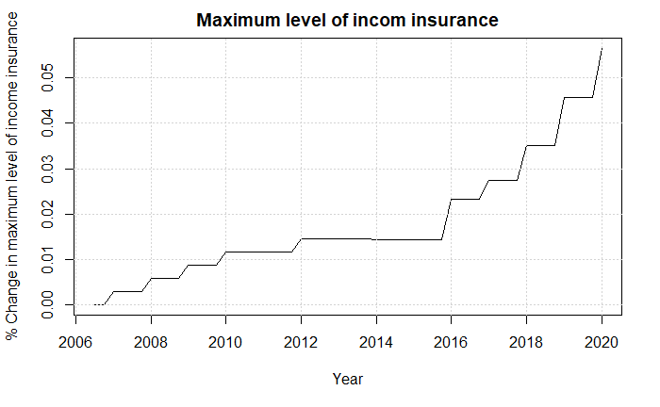

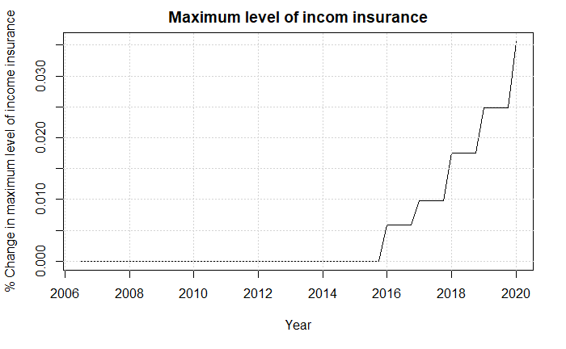

Comparing the effects including all the channels shows quit a large effect on the change in employed, decreasing the employed by more than 150.000 from 2006-2020.

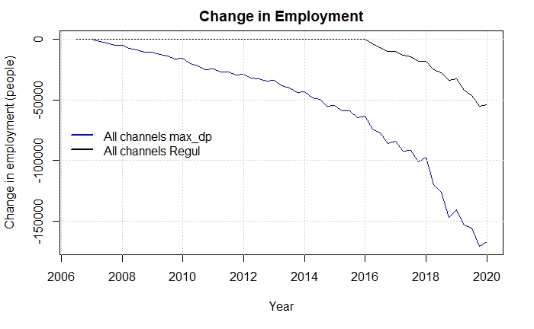

Looking at the change in employment using all the channels except productivity we get the following results:

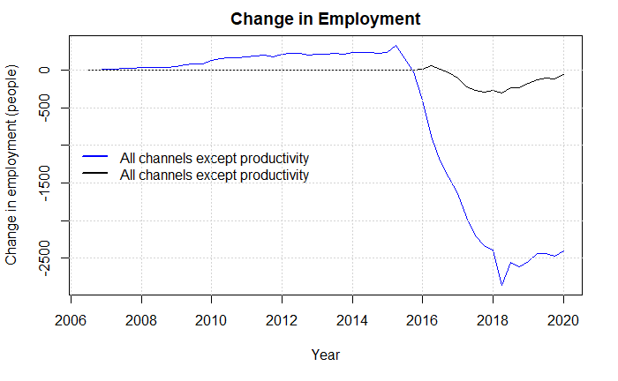

# Sensitivity analysis

## Demand channel

In this section we will perform a sensitivity test of the most influential parameters in the shocks. First, we will look at the estimate going into the equation of the average income insurance when performing the shock in scenario 1. We know that the estimate should be between 0.85 and 1 as the fraction of receivers of the maximum level of income insurance is 0.85. And no more than 100% can receive the maximum level.

Therefor we will test the effect of lowering this estimate to 0.85 assuming that only the people on maximum level of income insurance will experience the increase. On the other site most of the increases in the maximum level of income insurance comes from wage increases, which will also increase the level received by those not hitting the maximum level of income insurance, therefor we increase it to 0.99.

### Estimate of 0.85

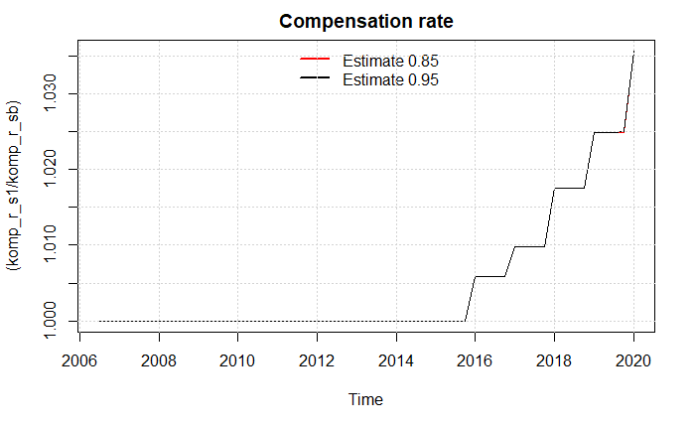

We see that the percentage change in the compensation rate is not affected by lowering the estimate, as the baseline value is equally lower before the shock as after the shock for the average level of income insurance. Instead looking at the GDP we see that lowering the estimate to 0.85, creates a weaker reaction in GDP

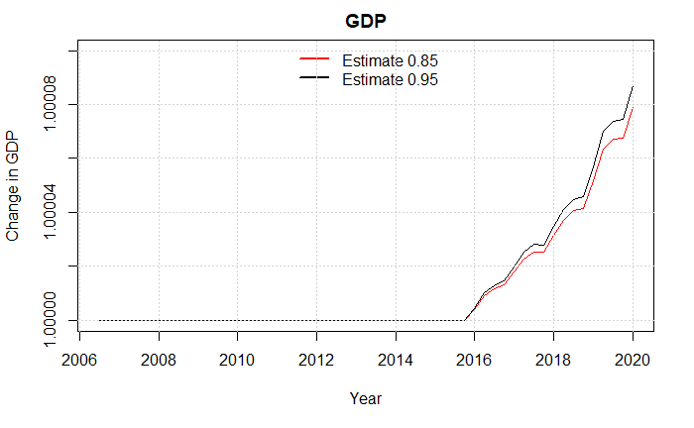

### Estimate of 0.99

We can see the opposite effects plays in when increasing it from 0.95 to 0.99.

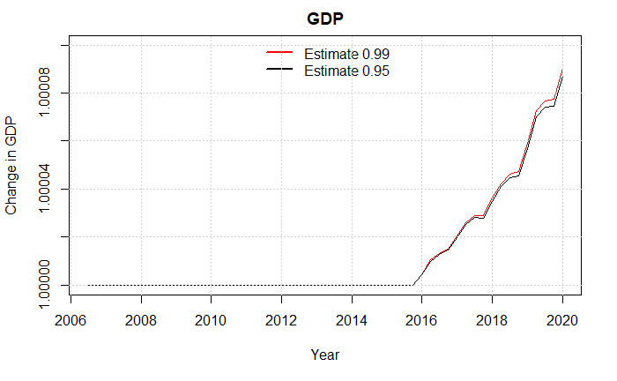

It seems like changes to the estimate going into the average level of income insurance doesn’t affect the final results much, as noted before the span of an increase in employment is from 223 (estimate of 0.85) to 254 (Estimate of 0.99)

## Wage channel

One of the most central parameters for the wage channel is the limit that the worker unions will allow for the wage gap. As we don’t observe this limit in the data it is hard to find any evidence that backs up the value of this parameter. Even though setting this parameter is tough, much literature presented in section three confirms that the maximum level of income insurance should affect the wage negotiations. In this model assumed through the limits of the wage gap. We will therefor now test how changes to the limit away from 40% affect the results of the model.

### Wage gap limit of 38%

When lowering the limit of the wage gap to be 38% of the wage, the effect is never going to play into the model, as drops in the wage-gap below 38% will correct itself in the next period. As the targeted wage is only affected by the wage gap in quarter 4 the year before, we can see that the gap can get under 38% but correct itself. As can be seen by the ploy below this happens two times but has no effect on the targeted wage.

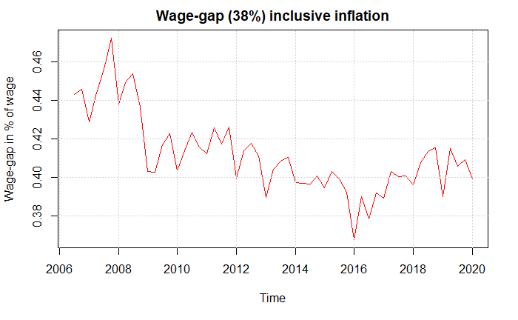

### Wage gap limit of 42%

Increasing the wage-gap limit to 42% of the wage, ends up increasing the targeted wage by more than 5% in 2020, as can be seen below.

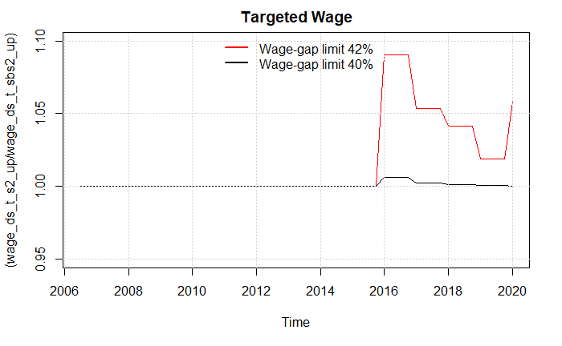

As worker unions now demand higher wages at wage negotiations the wages will increase, in 2020 with approximately 1%

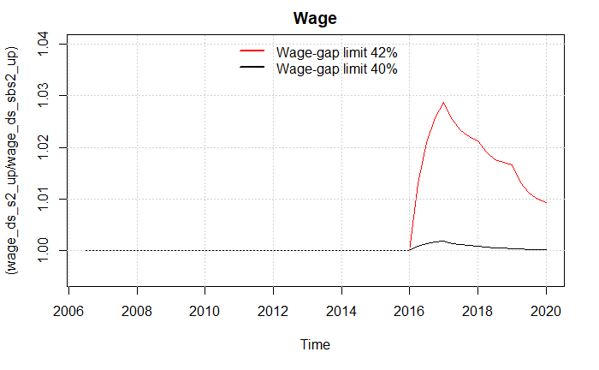

As firms are experiencing higher costs in the form of wages, the inflation will now increase.

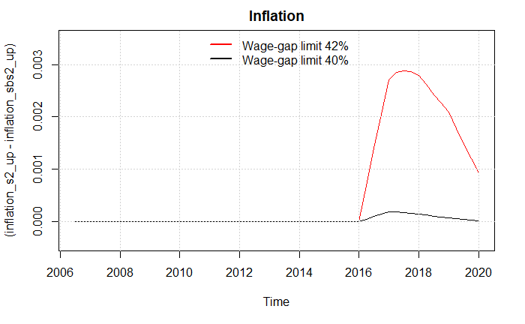

As in Scenario 2 when introducing the wage channel, we can look at the most central variables when changing the wage-share in the economy, the investment, consumption and trade-balance.

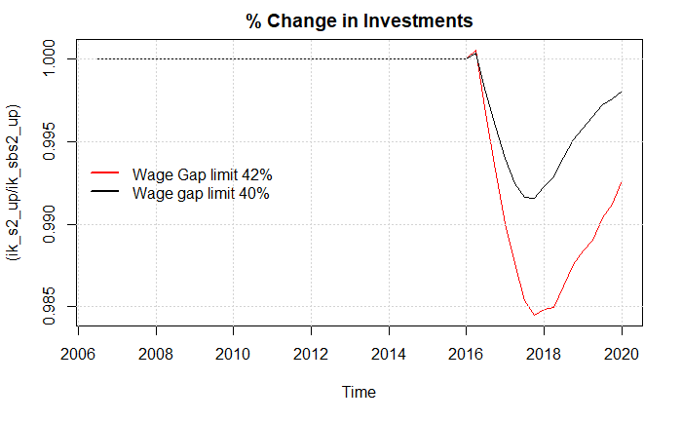

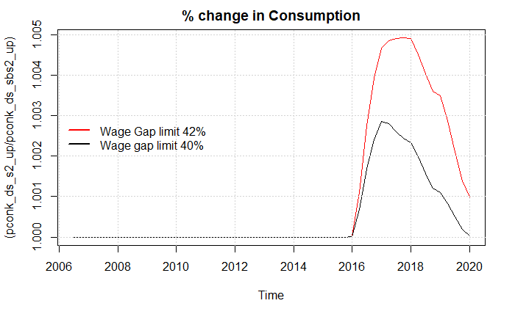

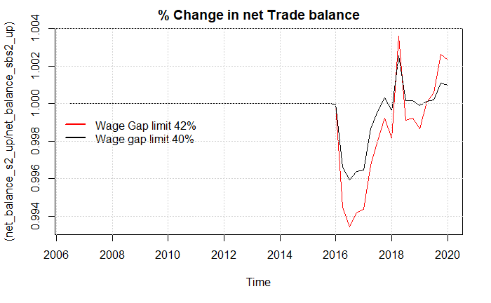

Again, we see that the fall in investments outweigh the increase in consumption and trade-balance, creating a contraction of the economy, as can be seen in the plot below showing the GDP:

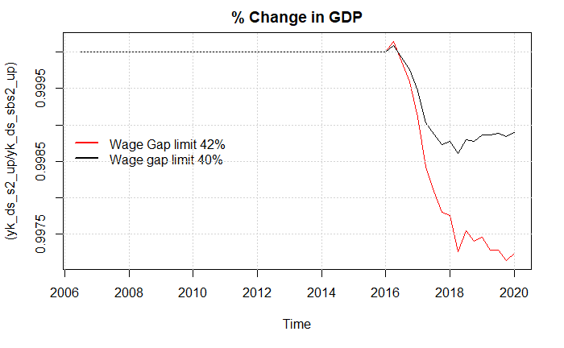

We can see the fall in employment is quite large now, showing a fall of 8000 people. Therefor we can see that one of the central effects that can play into the effects of an increase in the level of income insurance is the way the workers union uses this level to negotiate wages.

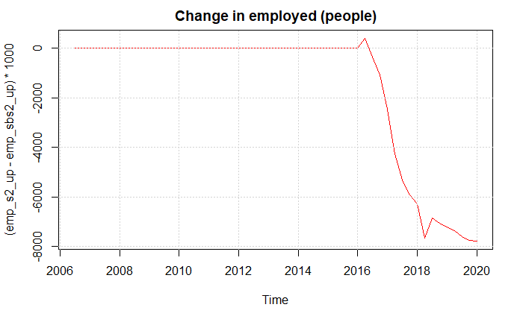

## Productivity channel

We saw in scenario 3 and 5 that the productivity channel clearly was the one showing the largest effects on employment and output in the economy. Also, this channel is the most questionable looking at the empirical evidence in the literature, as presented in section 3. Looking at the estimate of average income insurance on the productivity, it could be argued that other effects correlated with both average income insurance per person and productivity (for example technology). Therefor the estimate could be expected to have an upward bias. Therefor we will now test how lowering the estimate of average income insurance effects the productivity channel.

### Estimate of 0.1

We will now lower the estimate from 0.26 till 0.1 quite large decrease and look at the effects. First, we see a much lower increase in productivity coming of the shock.

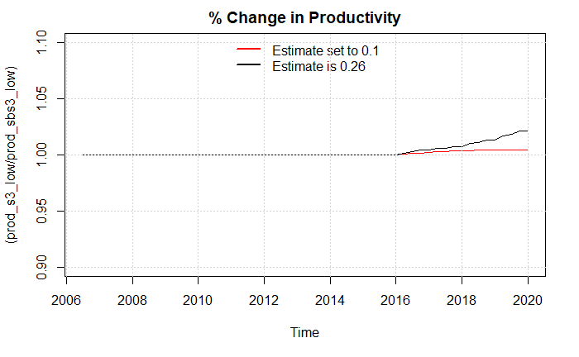

We now observe a fall in the GDP

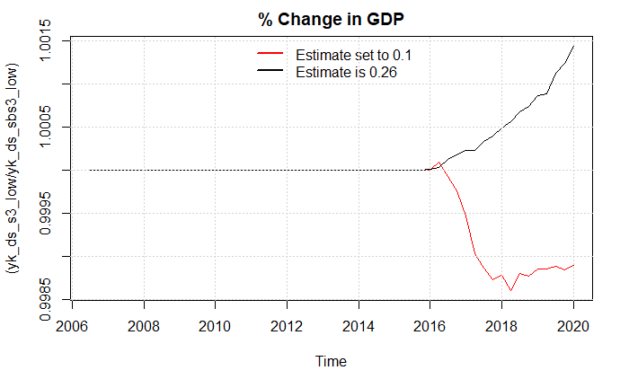

Also we now see a much lower decrease in the employment, only showing a drop of 3108 people in 2020, compared with 55086 people with an estimate of 0.26.

# Noter Til Discussion

1. Opstil de nyere resultater fra aggregerede undersøgelser, der viser større/mindre effekt end på mikro basis.
2. Fortæl alt efter hvordan estimaterne sættes i ovenstående resultater er det samme konklusion her, fx hvis det antages at wagegap er 38% for vi en makro effekt der trækker ned ad så den sammlede effekt under under mikro effekten. I alle andre eksempler ender den over mikro effekten, hvor meget over afhænger dog af hvordan man sætter parametre (Måske gå efter at få noget der minder om dobbelt effekt af Fredriksson og Söderström hvilket jeg fakisk også gør)

**Lalive**

The overall effect of rate (the macro effect of UI), is the sum of the mic

ities. The presence of significant market externalit macro effect of UI extensions are not the same. Estimates of the effects of UI ben- efits on search effort using variation in UI across individuals within a labor market capture micro effects of UI and do not provide enough information to assess the full welfare implications of variations in UI benefi

Brug det med at der ingen stor effekt er på vacancies ved små åbne økonomier.

**Fredriksson (Husk det er en stigning i max_dp % af løn mener jeg)**

One problem with the macro based results is policy endogeneity For instance, a study of UI benefit extensions at the state level is complicated by the fact that US federal law mandates that benefits are extended when unemployment is high.

One approach to get around the issues raised by policy endogeneity is to use border counties in different U.S. states as a source of identifica tion; see Hagedorn et al. (2013)

Hagedorn et al. (2013) find that the extensions of UI benefit duration have very large positive effects on unemployment; Chodorow Reich et al. (2019) conclude that extensions of UI benefit duration have no impact on unemployment.

The macro effect of UI on unemployment is of considerable interest from a normative point of view. Landais et al. (2018) show that if market tightness is not efficient (i.e., the Hosios, 1990, condition does not hold), then the size of the macro elasticity relative to the micro elasticity of UI is important in determining the optimal level of UI. If the macro elasticity equals the micro elasticity, then the Baily-Chetty formula applies directly (Baily, 1978; Chetty, 2006). If the macro elasticity is greater than the micro elasticity, and there are aggregate inefficiencies, then UI benefits should be set lower than the level dictated by the Baily-Chetty formula. A key question is thus whether the macro elasticity is greater than the micro elasticity. A further contribution of our paper is that we estimate both elasticities using a coherent framework and data from the same

We find that the macro elasticity is approximately twice as large compared to the corresponding micro elasticity (1.4–1.5)

We examine two explanations: (i) that wage pressure rises following an increase in UI generosity; (ii) that there is spillover across regions, in particular if regions are highly integrated.

Columns (6)–(8) examine whether the results are sensitive to the choice of the particular measurement of UI generosity. Instead of using the log replacement rate, we use the replacement rate (in levels) in column (6), log benefits in column (7), and in column (8) we use a weighted average replacement rate, which weights individuals by the probability of collecting unemployment benefits. The estimated un- employment response is slightly lower in columns (6) and (7).

The purpose of this section is to provide some evidence on why the macro effect of UI is greater than the micro effect. One reason for this in the standard version of the search-matching model (see Pissarides, 2000), is that UI benefits improve workers' outside options and, thus, increase bargained wages. Higher wages reduce profits per worker. Firms respond by creating fewer jobs and, so, market tightness is reduced and unemployment increases – over and above the direct effect coming from reduced search incentives among unemployed workers.

To examine the impact of UI replacement rates on wages, we use our baseline specification, but with average log wages as the outcome. Table 4 presents the results. Columns (1) and (2) show the results of un- weighted and weighted specifications, respectively; column (3) contains the estimates for the local labor market level. Our baseline specification renders an elasticity of 0.27; see column (1). There is a marginal drop in the coefficient of interest in the weighted regression, and a marginal increase when the analysis is conducted at the local labor market level.

Nevertheless, the results in columns (7)–(9) do not change the overall impression that wages rise as a result of increase in UI generosity. Overall, the elasticity of interest is in the order of 0.2–0.3.

**Steven Dieterle**

We re-examine the state boundary-based evidence by documenting the fundamental tradeoff between two sources of bias when using such approaches. Boundary-based approaches require that the areas being compared on either side of the border would experience similar labor market conditions in the absence of a difference in UI duration. Effectively, this requires similar industry structure, labor productivity, and agglomeration effects on either side of the border. In the current context, it also means that the economic shocks that triggered UI extensions in one state must evolve over space in such a way that areas on either side of the border are affected similarly. Border-based approaches also require that the effect of the policy is concentrated on one side of the border. If these two conditions hold, then differences in outcomes at state boundaries can be attributed to the the longer UI available in one state and not the other.

Ignoring aggregation issues and comparing county-level outcomes at boundaries, we estimate large negative effects of the UI extensions on unemployment. These uncorrected estimates suggest that a permanent extension of UI benefits to 99 weeks would raise unemployment from a baseline of 5 percent to 9.9 per- cent, closely matching the results from HKMM. However, correcting for the use of county level aggregates, we find much smaller effects. For example, control- ling for a linear function of distance to the border, we find that permanently extending UI benefits to 99 weeks would raise unemployment from a baseline of 5 to 5.5 percent. We also find suggestive, but imprecise, evidence that wages and earnings did not change discontinuously at state boundaries.

While focusing attention on smaller areas closer to the border helps match the experimental ideal of comparing similar areas facing different UI duration, that proximity may also increase the possibility that the policy affects outcomes on both sides of the border, violating the second requirement for identifying policy effects at boundaries. In a small area with a connected labor market, the effect of UI extensions may spillover the border since workers and firms have easy access to potential employment matches in the other state.

By analyzing patterns in cross-border employment by individuals, we find new evidence that workers who live near the border respond to changes in benefits in the neigh- boring state by shifting employment, not necessarily residence, from the low- to the high-benefit state.

Combining the two sets of results highlights the tension between the two sources of bias— while focusing on areas closer to state borders will likely reduce the upward endogeneity bias from the shocks that triggered UI extensions, it will simultaneously increase the importance of the attenuation bias from the treatment spillovers. As both of these effects go in the same direction— toward smaller point estimates when considering areas closer to the border— it is impossible to disentangle the two without imposing strong assumptions on how they differentially evolve over space. Together this tradeoff suggests that the boundary-based estimation strategies are ill-suited for directly identifying the macro effects of UI extensions on unemployment rates.

Following HKMM, we also present calculations based on the estimates for the implied unemploy- ment rate starting from a base rate of 5 percent under two counterfactuals: one based on the average increase in benefits and one assuming a change to the maximum benefit duration.

In Column (1) of Table 4.1 we present RD results not controlling for dis-

tance. The implied unemployment rates from the policy counterfactuals— 9.1 percent for change to the average benefit duration and 9.9 percent for a change to the maximum duration— are quite close to the corresponding BPFE esti- mates from HKMM of 8.6 percent and 10.5 percent. Controlling for a linear function in distance in Column (2) (captured here by including the population- weighted mean distance from the border for a county) produces considerably smaller estimates that are no longer statistically significant. The implied un- employment rate starting from a baseline of 5 percent for the two policy coun- terfactuals drops to 5.5 percent. We

Conclusion:

We raise two main issues. The first is partially a data issue— the available county-level labor market measures used may be aggregated at too high level to ensure a clean quasi-experimental comparison across border counties. The second is a conceptual issue— the same factors that make an area a good control group for a neighbor across the border may make it more likely that the policy effect spills over the border contaminating the quasi-experimental control group.

On the whole, our results provide evidence against a large vacancy reduction effect of UI extensions and suggest caution in using boundary-based approaches to identify the causal effects of EB and EUC extensions.

Our measurement error-corrected RD also serves as an attractive alterna-tive to the BPFE approach. It highlights the potential for bias from the more common geographic RD approach of calculating distance to the border using geographic centroids,16 and is particularly useful in the case with the UI ex- tensions during the Great Recession, when policy adoption is drive by contem- poraneous factors, rather than more systematic differences between the regions being studied.

**Boone**

Keynesian theory predicts a positive employment effect of UI provision during recessions via stimulating aggregated demand (Summers (2010); Congressional Budget Office (2012)). In contrast, search-and-matching models suggest that extensions could raise reservation wages and lead to lower vacancies and employment (Mitman and Rabinovich (2014)).

Unfortunately, a small set of recent empirical papers has delivered a mixed verdict on the size of the macro effect of the policy (Chodorow-Reich and Karabarbounis (2016); Coglianese (2015); Hagedorn et al. (2015); Hagedorn et al. (2016); Johnston and Mas (2015)).

We find no evidence that UI benefit extensions substantially affected

county-level employment. For the full sample OLS regressions, our point estimates for the e?ect of expanding maximum benefit duration from 26 to 99 weeks range from 0.21 to 0.43 percentage points of the employment- to-population (EPOP) ratio. These estimates are not significantly di?erent than zero, and the most precise estimates allow us to rule out e?ects on EPOP more negative than -0.32 percentage points at the 95% confidence level. For comparison, the total change in EPOP over the course of the Great Recession was about -3 percentage points in our sample.

In contrast to the large empirical literature on the micro-level labor supply elasticity, there are relatively

fewer papers that have estimated the macro-level impact of unemployment insurance on overall employment. The papers most closely related to ours are Hagedorn, Karahan, Manovskii and Mitman (2015)—hereafter HKMM—and Hagedorn, Manovskii and Mitman (2016)—hereafter HMM. Like us, these papers use a BCP strategy; HKMM provide evidence complementary to us that the BCP strategy mitigates the endogeneity problem. However, they both estimate large negative e?ects of UI on aggregate employment. HKMM

Our findings are also consistent with Marinescu (2015), who finds that UI benefit extensions during the Great Recession decreased job applications but not posted vacancies, implying a modest impact of the extensions on overall job finding and unemployment rates.

**Spørgsmål nr. 270**

På baggrund heraf skønnes det, at den højere dagpengesats vil medføre en lavere

afgang fra dagpenge til beskæftigelse, hvilket skønnes fuldt indfaset at reducere

den strukturelle beskæftigelse med ca. 1.600 fuldtidspersoner ved at afskaffe min-

drereguleringen af dagpengene fra 2021 og frem til og med 2025. Adfærdsvirknin-

gen følger af, at ydelsen i dagpengesystemet er højere.

Den højere ydelse skønnes derudover at medføre en øget tilgang til dagpengesyste-

met, og dermed reducere den strukturelle beskæftigelse med ca. 1.300 fuldtidsper-

soner fuldt indfaset. Adfærdsvirkningen følger af en forventningseffekt for beskæf-

tigede om en højere dagpengeydelse i tilfælde af ledighed. Det forudsættes altså, at

ydelsesstigningen reducerer sandsynligheden for at finde ny beskæftigelse blandt

personer, som er på vej til at indtræde i dagpengesystemet

–

fx personer, som er

blevet opsagt, men først indtræder i dagpengesystemet efter en opsigelsesperiode.

Den samlede adfærdsvirkning skønnes på den baggrund at medføre et fald i den

strukturelle beskæftigelse på ca. 2.900 fuldtidspersoner. Det svarer til offentlige

merudgifter på ca. 900 mio. kr. efter skat og tilbageløb, hvor de 500 mio. kr. kom-

mer som følge af den højere ydelse i dagpengesystemet og de resterende 400 mio.

kr. fra tilgangseffekten

**Spørgsmål nr. 64**

Afskaffelse af mindrereguleringen af dagpenge i årene 2021-2023 skønnes fuldt indfaset i 2025 at medføre en varig negativ arbejdsudbudsvirkning på knap 2.900 fuldtidspersoner og en tilsvarende stigning i antallet af dagpengemodtagere

**Dagpenge model**

# Discussion

In the previous section we analyzed the effect of including macro founded effects of the suppressing of the rate regulation percent. In total we analyzed 4 effects neglected in the income insurance model. First the demand channel resulted in adding 222 - 254 more employed, the wage channel removed 0-3500 employed, the insurance rate channel added 300 employed. Lastly, the productivity channel removed 3108-55086 employed. As mentioned, there are lack of empirical evidence for the productivity channel, and the results of this should not be fully trusted.

When discussing a political decision like suppressing the rate regulation rate, it is radical to know the relationship between the macro elasticity and micro elasticity in the Danish economy. As of this point no one have compared these for the Danish economy, making the income insurance models results “useless”. When not knowing the macro elasticity relative to the micro elasticity of income insurance it is not possible to make the right political decisions. If the macro elasticity equals the micro elasticity, then the Baily-Chetty formula applies directly (Baily, 1978; Chetty, 2006). If the macro elasticity is greater than the micro elasticity, and there are aggregate inefficiencies, then income insurance should be set lower than the level dictated by the Baily-Chetty formula. A key question is thus whether the macro elasticity is greater/lower or equal to the micro elasticity. (Svenskerne)

Most of the literature touching on the relationship between the macro and micro elasticity is coming from the US (Boone, **Dieterle, Hagedorn … )** most of the papers use The Great Recession which brought a series of UI benefit extensions that were in many ways unprecedented in the United States (Dieterle). The results of these empirical tests are mixed and not giving a clear view of the relationship between the macro and micro elasticity. One reason for the mixed results could be that all the papers use causal effects methods to estimate their results using boarder-based approaches, this puts up two conditions: First, it require that the areas being compared on either side of the border would experience similar labor market conditions in the absence of a difference in UI duration. Second, it also requires that the effect of the policy is concentrated on one side of the border, meaning the effects on one site of the border can’t spill over to the other site. (Dieterle) argues that not all papers have been able to fulfill these conditions, making the results mixed.

A newer study from Sweden (Svenskerne) uses changes in the replacement rate of the wage when going to unemployment using the heterogeneity in high-wage and low-wage, here it is assumed that lowering the ceiling reduces benefit generosity more in high-wage regions, since high-wage regions also tend to be low-unemployment regions. (Svenskerne) finds that the macro elasticity in Sweden is twice as large as the micro effect with a macro elasticity of 3 compared to a micro elasticity of 1.4-1.5.

They argue that the main effect is that wage pressure rises, following an increase in UI generosity. (Svenskerne) finds empirical evidence that wages rise as a result of increase in UI generosity. Overall, the elasticity of interest is in the order of 0.2–0.3. In comparison to the results we get, we also conclude that it is the wage-channel leading the fall in employment.

The results of a wage increase presented by (Svenskerne) is that Firms respond by creating fewer jobs and, so, market tightness is reduced and unemployment increases – over and above the direct effect coming from reduced search incentives among unemployed workers. But they never show any evidence for this channel looking at the vacancies, another study looking at this effect is Marinescu (2015) finding no effect on vacancies when looking at the effects of a more generous income insurance program. We use the post-Keynesian explanation of wages affecting the investments, consumption, and net trade balance explained in scenario 3.

To compare our results, we use the same idea as (Lalive) where calculating the overall effect (the macro effect), is the sum of the micro effect plus market externalities. So, if finding significant market externalities as we do in our study, we can use those together with the micro effects of the income insurance model to get an idea of the relationship between then macro and micro elasticity.

The micro elasticity for Denmark is estimated using the model of the IS- commission, the ministry of employment in 2020 received a question for calculating the effects of removing the suppressing of the rate regulation rate in the period of 2021-2023. In the response it is estimated that the removing of the suppressing will result in an increase of 2.25% in the level of income insurance. In total this increase will lower employment by 2900 people, they further split the effect up to the one estimated from the exit-rate (1600 people) and the one for the approach-rate (1300 people). As mentioned by CEVEA the effect of the controversial estimate for the approach effect is approximately 45% of the total effect. (spg 127)

When estimating the micro elasticity, we will therefor follow the results from (DØRS 2022) who argues that the estimate for the approach effect used in the IS- model is twice as large as what newer literature suggests. We will also look towards the case in which this effect is totally neglected as argued by (LO, CEVEA, FH) and as the literature is still very sparse regarding this effect.

Using the results from the above estimations we calculate the micro elasticity of the level of income insurance on unemployment to be 0.66, when using the argumentation from (DØR 2022) we find that the elasticity drops to 0.51, the last estimation removing the approach effect entirely we find an elasticity of 0.36.

When calculating the macro elasticity, we have the option to just add the effects of the different channels independently, this will make it easier to pinpoint which effect is contributing with how much, this method will though remove the interaction between the different channels therefor all channels will be included as in scenario 5 for calculating the macro elasticity, and we will use the channels independently to get an idea of how much each channel contributes to the total effect. We have decided to exclude the productivity channel because of the lack of empirical evidence for this channel. We estimate the macro elasticity to be approximately 0.25-0.3. This implies that the macro elasticity in Denmark is larger than the micro elasticity, thereby finding results comparable to the findings of (Sweden).

Looking at the channels independently, we clearly see that the leading effect is going through the wage-channel as also noted by (Svenskerne). As mentioned before (Svenskerne) argues that the increase in unemployment coming from the increase in wage is duo to lower incentives for companies to hire workers, as mentioned above they show no evidence for this effect, and other empirical findings suggest that this effect does not exist. In scenario 2 we gave another explanation towards the negative effect using a post Keynesian view in which the effect of changes in the wage share coming from a change in the wage would affect the economy in a positive or negative way. (Stockhammer) argued that small open economies as Denmark empirically were found to be profit-led, explaining the negative effects of the increase in wages.